Proof of Efficacy Document Lava Lamp
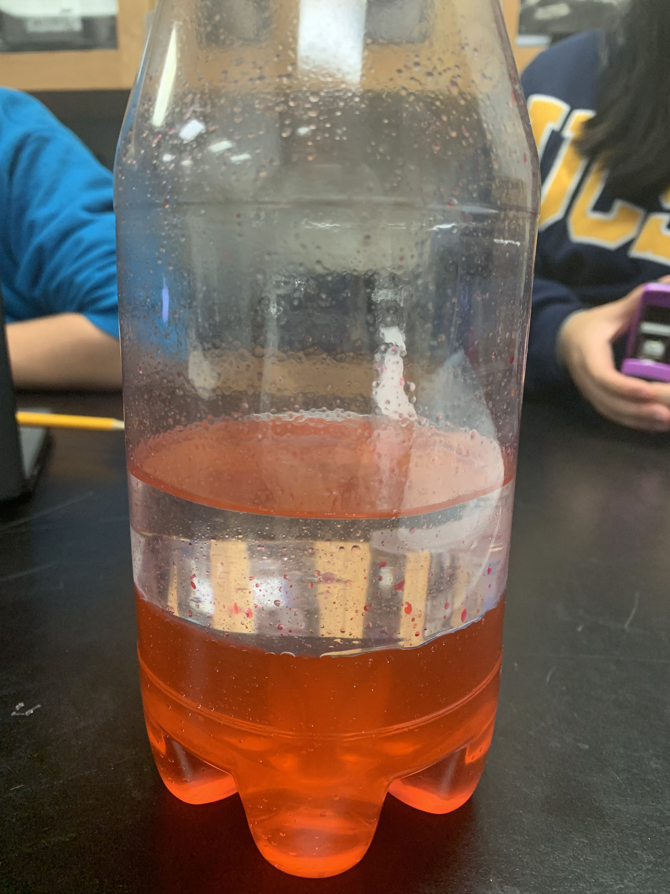

Our project essentially a temporary lava lamp. It uses the reaction between Alka-Seltzer and water which creates carbon dioxide gas, the chemical formula for the reaction is 3NaHCO3 + C6H5O7 → C6H5Na3O7 +3Co2 + 3H2O, which travels through the baby oil in red bubbles. We chose the color red because it gave the water a more lava feel, but also to help others see the reaction much more clearly. The alka-seltzer created chemical energy and from the chemical energy bubbles were created. The bubbles created kinetic energy. Our first model was completely different, it was oil on the bottom and 90% isopropyl alcohol on top of the oil. We wanted to heat the oil to make it move through the alcohol. But we changed this model because we had many troubles heating the oil enough to make it move. We first tried to heat the oil in calcium chloride mixed with water but we saw little change in the heat of the water, and wondered what else we could use to heat the water, so we decided maybe if we used sodium acetate in water. This showed us the best change in temperature but it was not enough to heat the oil enough. The first thing we should have tested was is boiling water was hot enough to heat the oil to make it move. But unfortunately it did not so we had the scrap the whole idea of heating the lava lamp with anything because unfortunately the water did end up melting our plastic bottle that the oil and alcohol were in. Leading us to for finished product now which is the alka-seltzer in water. Chemical energy is, when a chemical reaction occurs when a substance reacts with another compound or element. Kinetic energy is when an object is in motion or is put into motion. The main selling points of our project are that it is kid friendly, and that children would have a fun time putting this project together and watching it work. It also is very cheap and everyone most likely has the materials to build this whole reaction at home. There are some rules to follow for this project and it is that you should definitely not drink the the baby oil and do not leave the cap on the bottle once you drop the alka-seltzer into it, because it will cause a buildup of gas and might cause the bottle to explode if you put in enough alka-seltzers. The downside to using this is that it only lasts for a minute or two while if you were to purchase a real lava lamp, it can last pretty much for as long as you want, but it does not give the instant satisfaction that our project does. The data table for all our trials and models are below. Also the molecular blueprint.
 | Initial Temperature | Final Temperature | Amount | Q=Heat energy
Boiling water | 18.7C | 100C | 400 ml | 135,000J
Sodium acetate | 18.7C | 22.7C | 11.1 grams with 100 ml of water | 1,672J
Calcium chloride | 18.7C | 28.5C | 11 gram with 100 ml of water | 4,096J
Alka-seltzers | unknown | unknown | 6 tablets | Can’t be calculated due to lack of information

